Press Release – Portfolio Component

Angela Rolph

TARGETING:

1. Splash Learn-https://www.splashlearn.com/blog/best-magazines-for-kids/#:~:text=Cricket%20magazine%20is%20one%20of,young%20readers%20and%20aspiring%20writers.&text=Scholastic%20News%20provides%20age%2Dappropriate,tailored%20to%20different%20grade%20levels.

2. Time for Kids website-https://www.timeforkids.com/

3. Amazon-https://www.amazon.com/Stuart-Little-B-White/dp/0064400565

4. Disney Books-https://books.disney.com/age-range/3-5/

5. Golden Books-https://www.rhcbooks.com/brand/2823/disney-little-golden-books

6. Scholastic Books-https://www.scholastic.com/home

7. Highlights Magazine-https://shop.highlights.com/highlights-magazines-for-kids?gad_source=1&gclid=CjwKCAjw8fu1BhBsEiwAwDrsjOcDhXv7P2k1iCv3aSdTNtKpMKjafieV_czwIVtUu42Sz4-NVpSdUBoCweAQAvD_BwE

8. Magazine Haven-https://www.magazineheaven.com/children-s-magazines/disney-presents.html

9. Random House Children’s Books-https://www.rhcbooks.com/

10. PBS Kids-https://pbskids.org/

HOLD FOR RELEASE UNTIL August 17, 2024

Emerging Author Angela Rolph publishes a fantasy Collection, Dance or Die! A Collection of Distinctive Tales through Amazon.
NOW AVAILABLE FOR REVIEW

Sacramento, CA, November 23, 2023 – Angela Rolph announces the publication of THE LION AND THE LAMB: PRESCHOOL BOOK, a preschool book for 0-4 year olds. It is a romantic fairy tale, Beauty and the Beast Retelling, with a farm animal twist. This children’s book will be released on November 23, 2023, for $9.99 on Amazon Kindle.
Dance or Die! A Collection of Distinctive Tales is a fantasy, mystery, romance, sci-fi, comedy, tragedy, suspense, horror, and crime fiction collection that packs a powerful punch. It will leave you on the edge of your seat, dying to know what comes next. It contains game writing, short manuscripts, short stories, and a story bible. It will take you on a roller coaster ride you never expected. You will fall in love with the characters and the love that engulfs you. You will become immersed in the stories like the author is. You will not want this collection to end on the last page. This collection takes you on a unique adventure you will surely cherish for many years.

Writer’s Bio:

Angela Rolph is a novelist. She writes romance, sci-fi, humor, suspense, sci-fi, horror, comic, mystery, fantasy, and tragedy. Angela will graduate with her BFA in creative writing from Full Sail University in September 2024. She is a member of the creative writing club at Full Sail University. Angela also loves art and drawing cartoons. She is a member of the VFW Auxiliary. Angela enjoys simple pleasures, doesn’t waste moments, and cherishes every minute of its beauty.

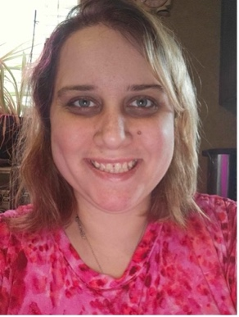

LinkedIn: https://www.linkedin.com/in/angela-rolph-63736839/

Facebook: https://www.facebook.com/rolpha11

Portfolio Website: https://aintthispeachy.wixsite.com/angela-rolph

Instagram: https://www.instagram.com/rolpha999/

Contact:

Angela Rolph

ALRolph@student.fullsail.edu

301 Willow Ave

South San Francisco, CA 94080-1446

(650) 554-8848

###

